Sprechprüfung (2 Prüflinge)

Candidate A

Topic: University Education

Situation:
You and your partner are working for an American organization which encourages disadvantaged young people to consider studying at university. You have been asked to create a poster promoting the organization and its aims.

Assignment 1:
- Describe and analyze your material.
- Briefly comment on your material.
Talk for 3 to 4 minutes.

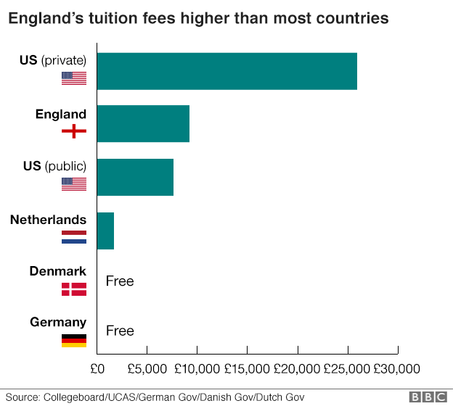
ANNUAL TUITION FEES, 2018
Assignment 2:
- Together with your partner, discuss how to encourage more young people to consider studying at university.
- Agree on which images and text to include on your poster.
Talk for 7 to 8 minutes.
Sprechprüfung (2 Prüflinge)

Candidate B

Topic: University Education

Situation:
You and your partner are working for an American organization which encourages disadvantaged young people to consider studying at university. You have been asked to create a poster promoting the organization and its aims.

Assignment 1:
- Describe and analyze your material.
- Briefly comment on your material.
Talk for 3 to 4 minutes.

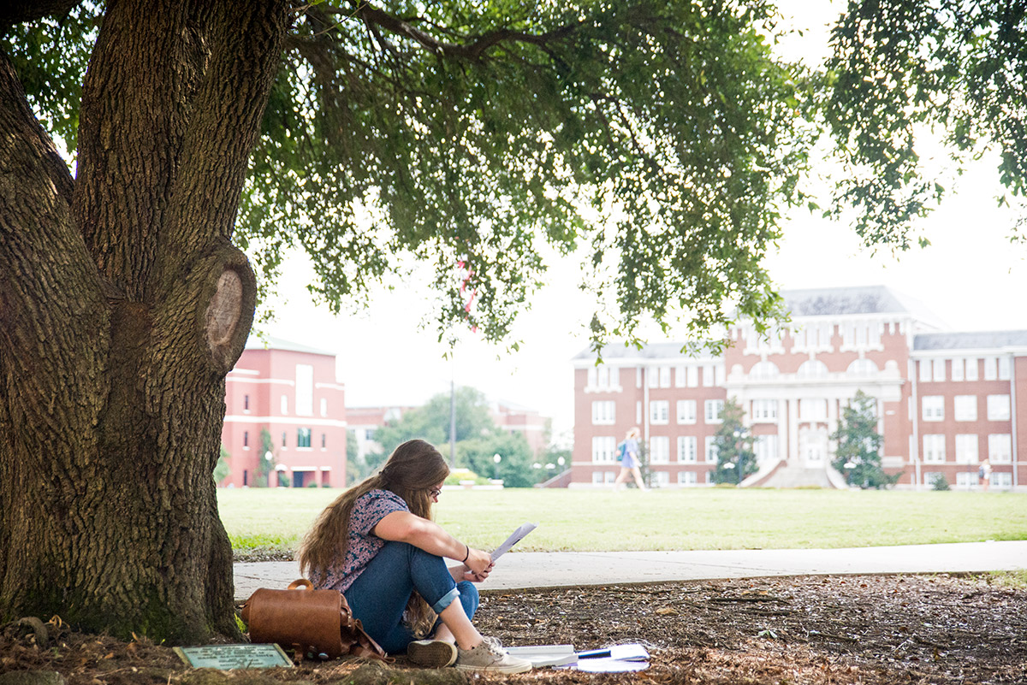
MEDIAN LIFETIME EARNINGS BY HIGHEST EDUCATIONAL ATTAINMENT
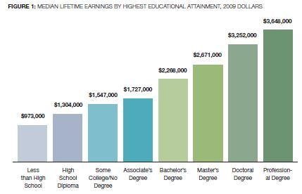
Report “The College Payoff: Education, Occupations, Lifetime Earnings,” by researchers at Georgetown University’s Center on Education and the Workforce, based on 2007-2009 American Community Survey data
Assignment 2:
- Together with your partner, discuss how to encourage more young people to consider studying at university.
- Agree on which images and text to include on your poster.
Talk for 7 to 8 minutes.
2. Examination proper (monologue parts: 3-4 minutes ; dialogue part: 7-8 minutes)

INTERLOCUTOR
Let us now begin with the main part of the speaking test. I am going to read the assignments for you. Then you will have three minutes to make yourselves familiar with the task sheet.

Situation:
You and your partner are working for an American organization which encourages disadvantaged young people to consider studying at university. You have been asked to create a poster promoting the organization and its aims.
Assignment 1: Describe and analyse your material.
Briefly comment on your material.
Talk for 3 to 4 minutes.
Assignment 2: Together with your partner, discuss how to encourage more young people to consider studying at university. Agree on which images and text to include on your poster.
Talk for 7 to 8 minutes.

Now you have three minutes to look at the task sheet. You may take notes on your task sheet.

While doing the task, please look at each other and listen actively. We will give you a signal when the minimum time has passed. (Der Zweitprüfer hebt nach Ablauf der Mindestzeit die Hand.)

Candidate B, turn over your task sheet. Candidate A, please start.

Wenn kein schülerseitiger Übergang von einem Monolog zum anderen erfolgt, greift der Prüfer ein:

Now it's your turn, candidate B.
Falls nötig: Candidate A, please turn over your task sheet.

Thank you. Now, move on to the second assignment. Remember to reach a consensus by the end of the task. You can look at your task sheets.

Grundsätzlich gilt, dass die Prüfer möglichst wenig sagen und möglichst wenig in das Prüfungsgeschehen eingreifen. Die nachfolgenden Zusatzimpulse ('follow-up prompts') sollen deshalb nur eingesetzt werden, wenn die Prüflinge ins Stocken geraten und ihre Redebeiträge nicht mehr selbstständig bzw. im zweiten Teil nicht mehr kooperativ fortführen können. Pro Prüfungsteil darf einer dieser Impulse verwendet werden, ohne dass es dabei zu einem Punktabzug kommt.

Follow-up prompts for monologue part:
- You could talk about the social benefits of studying.
- You could talk about your personal feelings on higher education.

Follow-up prompts for dialogue part
- You could talk about what governments can do to help disadvantaged students.
- You could talk about the way student life is presented in the media.

Thank you. This is the end of your test.

Quellen, zuletzt zugegriffen am 03.10.2021

Candidate A:
- http://curemysleepapnea.com/sleepsource/2015/03/26/sleep-affects-mental-health-college-students/
- https://mdxipe.wordpress.com/2018/12/14/student-debt-is-it-really-any-good/

Candidate B:
- https://www.msstate.edu/state-spotlight/2017/09/studying-shade
- https://thesocietypages.org/socimages/2011/08/10/lifetime-earnings-gaps-by-sex-and-raceethnicity/

