Abstract title goes here
Corresponding Author (correspondingauthor@amlap.com)¹, Author Two¹, Author Three² ¹Department of Something, Some University, ²Department of Something Else, Some Other University
This is a template for AMLaP 2026. All text, including this paragraph, is set in Helvetica 11pt. The title above is bold 11pt. Citations appear as numeric in-text citations and in the numerical order in the bibliography [1, 2].
Please follow these instructions:
- Submit the abstract in PDF format.
- No identifying information for anonymous review.
- Use color responsibly (accessible for color-blind readers).
- Page size: A4 with 2.5 cm margins.
- Font: Helvetica, 11 pt (Alternatively use Arial, 11 pt).
Paragraphs of the main body are fully justified with automatic hyphenation.
Authors are permitted one full A4 page of text, with a second page for supplemental examples, figures, and references. Authors working on non-English languages may include a third page with additional information about the language of study where this would be helpful to the reader. For example, where sentences require glossing, authors may wish to use use a third page to better present these data.
Changes to this template are allowed as long as they follow the overall guidelines.

References
[1] John J. Doe. A study on things. Architectures and Mechanisms for Language Processing 2026 — AMLaP 2026, 2026.
[2] Firstname Lastname. Title, any further information, 2026.
Figures and Tables
Figure 1: Example Figure Table 1: Example Table
A | B | C
1 | 2 | 3
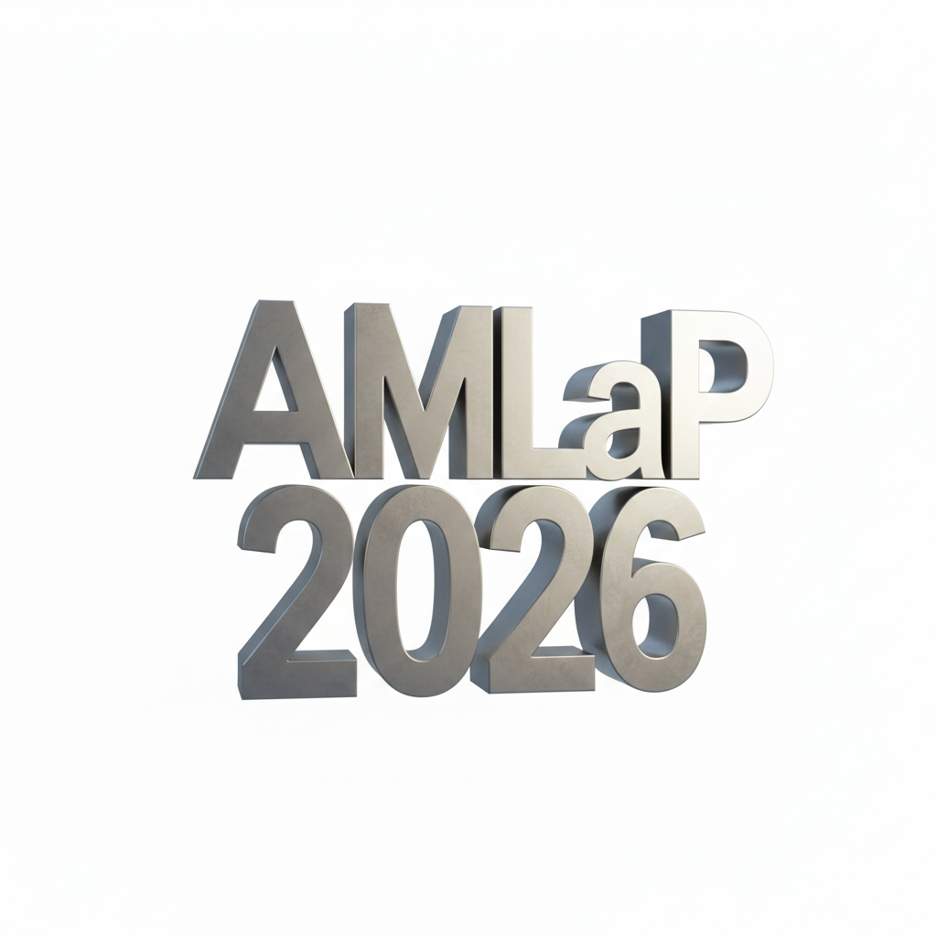

Optional Supplemental Information
Use this optional page for additional technical details if needed.

