Election proposal
to
Direct election
of the Homburg AStA External Affairs Department

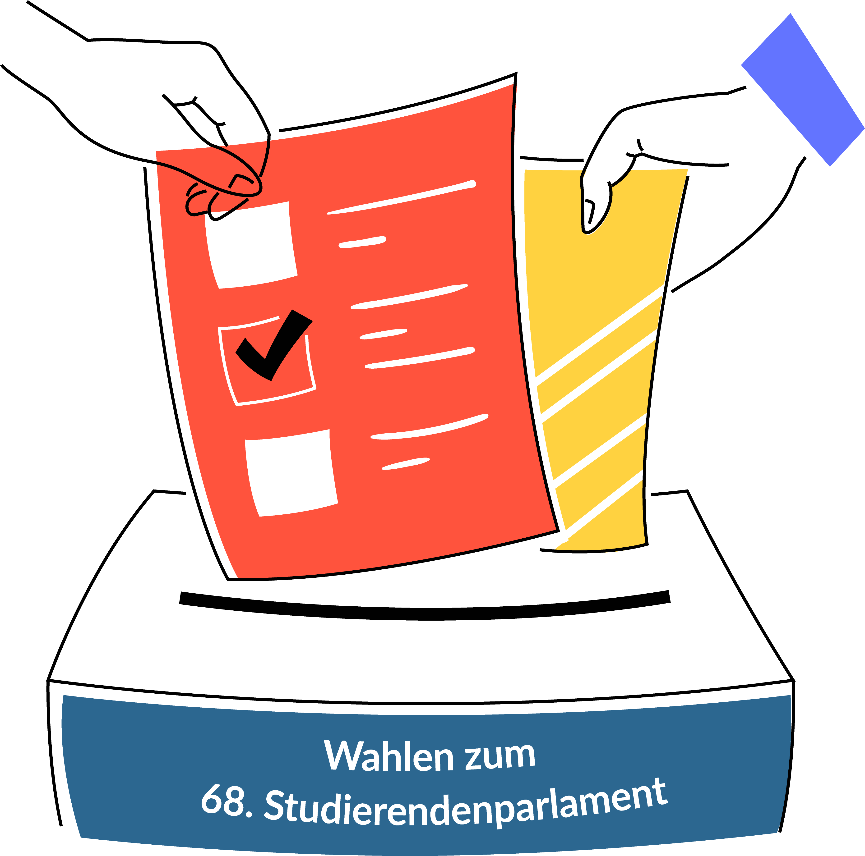

Instructions for an Election Proposal for the Direct Election (AStA Außenreferat Homburg)

Eligible voters Students of the Faculty of Medicine can stand for direct election to the AStA external department Homburg (passive right to vote). In order to stand for election for the AStA external department Homburg, an application (election proposal) must be submitted to the election officer.

Minimum requirements and optional information
An election proposal for direct election must contain:
- Surname, first name and field of study of the candidate and, in the case of an additional list candidature, the designation of the list [Annex 1];
- A passport photo of the person running for office;
- The matriculation number and signature of 5 students of the Faculty of Medicine who are entitled to vote (It is inadmissible to support oneself) [Annex 3];
- Further personal details (date of birth, matriculation number, e-mail address, address of the person running for office) as well as the written declaration of consent to candidacy [template attached].
The election proposal may contain:
- Information on memberships in political parties, organisations and offices held [Annex 1];
- A personal election manifesto of the person running [Annex 2].

Form and deadline
The application must be submitted in writing to the election officer of the StuPa elections (contact details can be found in the cover letter). The candidate must sign the application. Nominations for the elections to the 68th Student Parliament can be submitted until 10.06.2022 (submission deadline).

Review and publication
The election officer shall immediately check received election proposals with regard to their correctness with the election regulations and notify the person running for election of the result of his check. If the proposal shows deficiencies, the election officer shall request in his notification that the deficiencies be remedied without delay.
After expiry of the submission deadline (10.06.2022), deficiencies can only be remedied in the case of fundamentally valid election proposals. A valid election proposal does not exist if it has not been submitted in due time, the required supporting signatures are not available, the required declaration of consent is missing or the surname and/or first name of the person running for election has not been stated.
Valid, defect-free election proposals will be publicly announced by the election administration on 17.06.2022.

Candidate:
####Please enter and delete references####
First name Last name
Street number
Postcode City
Telephone number
E-mail
Election officer for the elections to the 68th Student Parliament of Saarland University

Mr. Ass.iur Veris-Pascal Heintz, LL.M.
AStA of Saarland University
Campus, Building A5 2
66123 Saarbrücken

Election proposal for the direct election for the AStA External Affairs Department Homburg in the context of the elections to the 68th Student Parliament

Dear Mr Heintz,
I hereby apply for the admission of my direct candidacy pursuant to § 9 Abs. 1 in conjunction with § 24 WO-StuPa. § 24 WO-StuPa for the AStA external department Homburg in the context of the elections for the 68th Student Parliament of Saarland University, which will take place from 4 to 7 July 2022.
I have enclosed the necessary completed enclosures (1, 2 and 3 if applicable), my personally signed consent forms and a passport photo.

With kind regards

###Please enter and delete notes ###
First name Last name

Attachments | Attached  Please tick
Annex 1 (Direct Election Proposal [General])
Annex 2 (Personal Election Programme)
Annex 3 (Support list)
Consent forms
Passport photo

Annex 1 |  | Direct election proposal (Homburg)
Details of the person standing as a candidate:
The following information is mandatory:
Name:
First name:
Study Subject:
Member of the Faculty of Medicine
The AStA department responsible for Homburg is elected directly. All students enrolled at Saarland University's Faculty of Medicine in the summer semester of 2022 are eligible to vote, with the exception of guest students, second-year students, junior and starter students.
I am enrolled at the Faculty of Medicine at Saarland University in the summer semester of 2022.
List affiliation
If you are standing for election to the 68th Student Parliament on a list, please state the name of the list on which you are standing:
###Please enter here###
_______________________________________________________
List designation
Membership in parties, organisations, offices held
This information is voluntary.

Annex 2 | Personal election programme
Name: |  |  | Your election proposal may include a personal election programme. The election programme will be published after the examination and acceptance of the election proposals by means of a notice in accordance with local practice and on the election website.
First name:
My election programme:

Annex 3 |  |  | Support list
To be accepted as a direct candidate, you need the support of at least 5 eligible students who are also members of the Faculty of Medicine. All students enrolled at the Faculty of Medicine of Saarland University in the summer semester 2022 are eligible to vote, with the exception of guest students, second-year students, junior students and starter students. It is not permitted to support oneself.

Candidate:
Name:
First name:
The following persons support the direct candidacy of the above-mentioned list for the elections to the 68th Student Parliament of Saarland University:
No. | Matriculation number |  |  | Handwritten signature
1
2
3
4
5
6
7
8

Personal data and declaration of consent (direct candidacy)
Personal data and written declaration of consent to direct candidacy
We require the following personal data in order to contact you and assign you. This data will only be used internally and will not be published. For data protection, please compare the data protection information for election proposals for the elections to the 68th Student Parliament in the appendix to this proposal and on our election website at: www.uni-saarland.de/page/stupa-wahl.html.

Personal details
Name:
First name:
Date of birth:
Matriculation number:
Street and house number:
Address suffix:
Postcode:
Place:
E-mail:
With my signature, I declare my consent to my candidacy for the elections to the 68th Student Parliament. With my signature, I also confirm that I have taken note of the information enclosed with the form and available on the StuPa elections website in accordance with Art. 13 DSGVO.
_______________________________________________  Date, Place |  | _______________________________________  Signature

Data protection information pursuant to Art. 13 of the General Data Protection Regulation (DSGVO) for election proposals
DATA PROCESSING OFFICER:
The Chief Electoral OfficerRA
Veris-Pascal Heintz LL.M.
E-mail:
wahlleiterstupa@uni-saarland.dePostanschrift:
Campus
Saarland
UniversityBuilding
A 5.2.
66123 Saarbrücken
DATA PROTECTION OFFICER:
Barbara PartzschE-Mail:
datenschutz@uni-saarland.dePostanschrift:
Standort MeerwiesertalwegP.O. Box
15 11 5066041
Saarbrücken
PURPOSES AND LEGAL BASIS OF DATA PROCESSING:
Your data is collected in order to be able to check and process the election proposal submitted by
you with regard to eligibility and to ensure the proper conduct of the election. Your data is collected on the basis of Art. 6 Para. 1 Sentence 1 e), Para. 3 Sentence 1 b) Basic Data Protection Regulation (DSGVO) and § 4 Saarland State Data Protection Act (SDSG).
DURATION OF STORAGE:
Your data will be stored
until 10 days after the election to the 68th Student Parliament of Saarland University.
AFFECTED RIGHTS:
You have the following rights under the General Data Protection Regulation:
- Right to information
If your personal data is processed, you have the right to receive information about the data stored about you (Art. 15 DSGVO).
- Right to data correction
If incorrect or incomplete personal data are processed, you have the right to rectification (Art. 16 DSGVO).
- Right to erasure
If the legal requirements are met, you may request the erasure or restriction of processing as well as object to processing (Art. 17, 18 and 21 DSGVO).
- Right to data portability
If you have consented to the data processing or if a contract for data processing exists and the data processing is carried out with the help of automated procedures, you may have a right to data portability (Art. 20 DSGVO).
- Right of complaint:
Every data subject has the right to lodge a complaint with the competent supervisory authority if he or she considers that the personal data have been processed unlawfully (for contact details of the data protection officers, see above).
DUTY TO PROVIDE DATA:
According to §§ 17, 19, 24, WO-StuPa
you are obliged to provide the following personal data when running for direct election: Surname, first names, date of birth, matriculation number, residential address (street, house number, postcode, town) and your e-mail address.
The contact data (e-mail address and postal address) will only be used for correspondence in the context of the candidature. Your data will not be used for any other purpose or passed on to third parties.

All students enrolled at Saarland University in the summer semester of 2022 are eligible to vote, with the exception of guest students, second-year students, junior students and starter students.

