Election proposal
to
Proportional representation

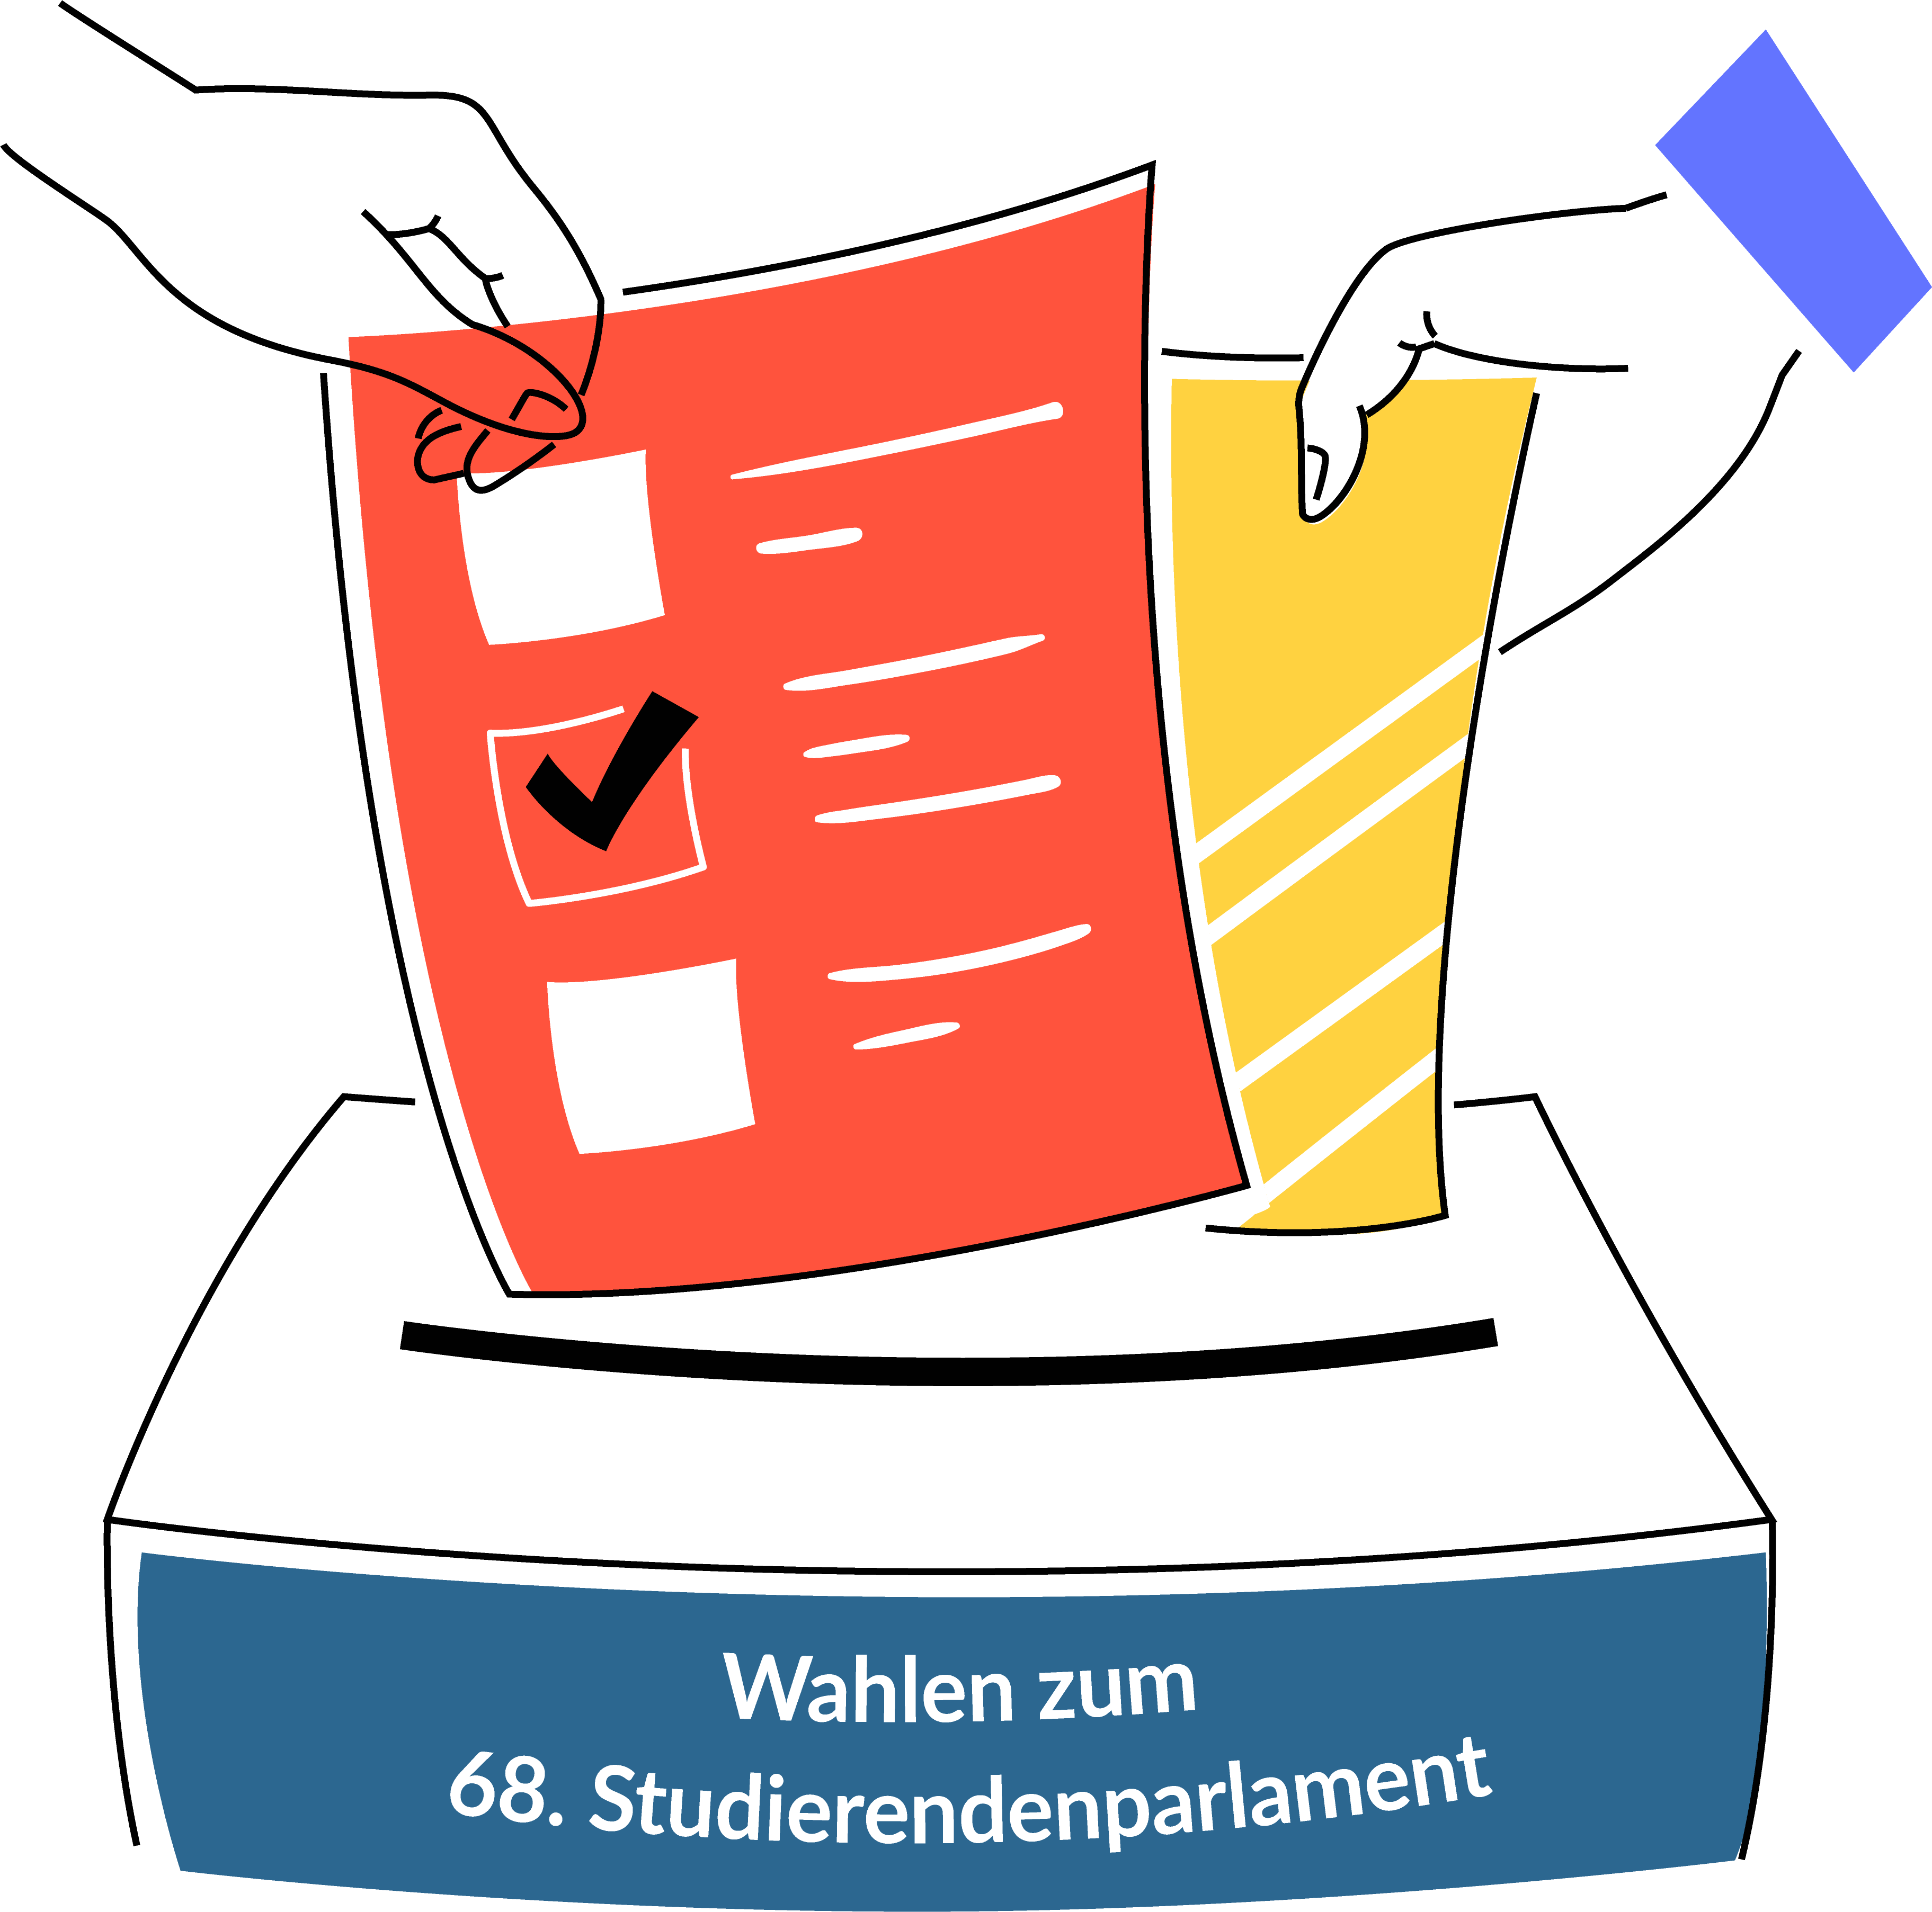

Instructions for an election proposal for proportional representation (list election)

Eligible voters Students can stand for election (passive right to vote). In order to stand for election to the student parliament, an application (election proposal) must be submitted to the election officer. In addition to direct candidacy , it is also possible to stand for election on a list. An electoral list groups together all persons who are jointly running for mandates in the student parliament.

Minimum requirements
An election proposal for proportional representation must contain:
- The name of the list (the name of the list must not give the impression that the list in question is identical with a body of the student body) [Annex 1];
- Surname, first name, field(s) of study of the candidates on the list in binding order (the list nomination must include at least three candidates) [Annex 1];
- A joint election manifesto (please enclose four printed copies with the application);
- Name, first name and contact details of a person responsible for the list [covering letter];
- The matriculation number and signature of 20 eligible students who support the list proposal and do not stand on it [Annex 2];
- The personal data of the persons running for election: Date of birth, matriculation number and address (This personal data will not be published, will only be used internally for the purpose of conducting the election and will be deleted or destroyed once the election result is unappealable) [Annex 3];
- A written declaration of consent to stand by each person standing on the list [template attached].

Form and deadline
The application must be submitted in writing to the election officer of the StuPa elections (contact details can be found in the cover letter). The person responsible for the list must sign the application. Nominations for the elections to the 68th Student Parliament can be submitted until 10.06.2022 (submission deadline).

Review and publication
The election officer shall immediately check received election proposals with regard to their correctness with the election regulations and shall notify the person responsible for the list of the result of his check. If the proposal shows deficiencies, the election officer shall request in his notification that the deficiencies be remedied without delay.
After expiry of the submission deadline (10.06.2022), deficiencies can only be remedied in the case of fundamentally valid election proposals. A valid election proposal does not exist if it has not been submitted in due time, the required supporting signatures are not available, a required declaration of consent is missing or a list proposal has less than three candidates.
Valid, defect-free election proposals will be publicly announced by the election administration on 17.06.2022.

List Responsible Person:
####Please enter and delete references####
First name Last name
Street number
Postcode City
Telephone number
E-mail
Chief Electoral Officer for the Elections to the 68th Student Parliament of Saarland University

Mr. Ass.iur. Veris-Pascal Heintz, LL.M.
AStA of Saarland University
Campus, Building A5 2
66123 Saarbrücken

Election proposal for the list election (proportional representation) for the elections to the 68th Student Parliament

Dear Mr Heintz,
I hereby apply for the admission of the following list pursuant to § 9 Abs. 1 in conjunction with § 19 WO-StuPa. § 19 WO-StuPa for the elections to the 68th Student Parliament of Saarland University, which will take place from 4 to 7 July 2022.
I have attached the necessary enclosures (1, 2 and 3), four copies of our election manifesto and the signed consent forms of the persons running for office.

With kind regards

###Please enter and delete notes ###
First name Last name

Attachments | Attached  Please tick
Annex 1 (list proposal)
Annex 2 (Support list)
Annex 3 (personal data)
Joint election programme
Consent forms

Annex 1 |  |  | List proposal (electoral list)
Name of the list
Please state the name of the list. It is not permissible to use such designations that are likely to create the impression that the list in question is identical with one of the organs of the student body (Organs of the student body are: The Student Parliament [StuPa], the General Student Committee [AStA] and the Council of Elders [ÄRat]).

The name of our list running for the elections to the 68th Student Parliament is:

###Please enter here###
____________________________________________________________
List designation
Electoral list
The list proposal is composed of the persons standing as candidates. Only persons who are eligible to vote may stand for election. All students enrolled at Saarland University in the summer semester of 2022 are eligible to vote, with the exception of guest students, second-year students, junior students and starter students. A list proposal can only be admitted if it consists of at least three candidates. Please note that the order of the list positions (LP) is binding!

LP | Name | First name |  | Subject | Subjects
Annex 2 |  | Support list
To be accepted as a list proposal, you need the support of at least 20 eligible students who are not candidates on the list itself. All students enrolled at Saarland University in the summer semester 2022 are eligible to vote, with the exception of guest students, second-year students, junior students and starter students.

Designation of the electoral list:
###Please enter here###
____________________________________________________
List designation
The following persons support the list proposal of the above-mentioned list for the elections to the 68th Student Parliament of Saarland University:
No. | Matriculation number |  | Handwritten signature
1
2
3
4
5
6
7
8
9
10
11
12
13
14
15
16
17
18
19
20
21
22
23
24
25

Annex 3 |  | Personal data (internal)
Personal data of the candidates
In order to check the election proposal, the requested personal data of the candidates is required. For data protection, please compare the data protection information for election proposals for the elections to the 68th Student Parliament in the appendix to this proposal and on our election website at: www.uni-saarland.de/page/stupa-wahl.html.

Designation of the electoral list:
###Please enter here###
_____________________________________________________
List designation
Personal data
LP | Name, first name |  | Date of birth | Marticle number | Address  (Street, house number, postcode, town)
1.
2.
3.
4.
5.
6.
7.
8.
9.
10.
11.
12.
13.
14.
15.
16.
17.
18.
19.
20.
21.
22.
23.
24.
25.
26.
27.
28.
29.
30.
31.
32.
33.
34.
35.
36.
37.
38.
39.
40.
41.
42.
43.
44.
45.
46.
47.

Declaration of consent to list candidacy
Written declaration of consent to list candidacy
A signed declaration of consent must be submitted by each candidate of the list proposal. Only those candidates who have submitted a declaration of consent can be considered. For data protection, please compare the data protection information for election proposals for the elections to the 68th Student Parliament in the appendix to this proposal and on our election website at: www.uni-saarland.de/page/stupa-wahl.html.

Designation of the electoral list:
###Please enter here###
__________________________________________________
List designation
Personal details
Name:
First name:
Date of birth:
Matriculation number:
Street and house number:
Address suffix:
Postcode:
Place:
E-mail:
With my signature, I declare my consent to my candidacy for the elections to the 68th Student Parliament. With my signature, I also confirm that I have taken note of the information enclosed with the form and available on the StuPa elections website in accordance with Art. 13 DSGVO.
_______________________________________________  Date, Place |  | _______________________________________  Signature

Data protection information pursuant to Art. 13 of the General Data Protection Regulation (DSGVO) for election proposals
DATA PROCESSING OFFICER:
The Chief Electoral OfficerRA Veris-Pascal Heintz LL.M.
E-mail:
wahlleiterstupa@uni-saarland.dePostanschrift:
Campus
Saarland
UniversityBuilding
A 5.2.
66123 Saarbrücken
DATA PROTECTION OFFICER:
Barbara PartzschE-Mail:
datenschutz@uni-saarland.dePostanschrift:
Standort MeerwiesertalwegP.O. Box
15 11 5066041
Saarbrücken
PURPOSES AND LEGAL BASIS OF DATA PROCESSING:
Your data is collected in order to be able to check and process the election proposal submitted by
you with regard to eligibility and to ensure the proper conduct of the election. Your data is collected on the basis of Art. 6 Para. 1 Sentence 1 e), Para. 3 Sentence 1 b) Basic Data Protection Regulation (DSGVO) and § 4 Saarland State Data Protection Act (SDSG).
DURATION OF STORAGE:
Your data will be stored
until 10 days after the election to the 68th Student Parliament of Saarland University.
AFFECTED RIGHTS:
You have the following rights under the General Data Protection Regulation:
- Right to information
If your personal data is processed, you have the right to receive information about the data stored about you (Art. 15 DSGVO).
- Right to data correction
If incorrect or incomplete personal data are processed, you have the right to rectification (Art. 16 DSGVO).
- Right to erasure
If the legal requirements are met, you may request the erasure or restriction of processing as well as object to processing (Art. 17, 18 and 21 DSGVO).
- Right to data portability
If you have consented to the data processing or if there is a contract for data processing and the data processing is carried out with the help of automated procedures, you may have a right to data portability (Art. 20 DSGVO).
- Right of complaint:
Every data subject has the right to lodge a complaint with the competent supervisory authority if he or she considers that the personal data have been processed unlawfully (for contact details of the data protection officers, see above).
DUTY TO PROVIDE DATA:
According to §§ 17, 19, 24, WO-StuPa,
you are obliged to provide the following personal data when running for direct election: Surname, first names, date of birth, matriculation number, residential address (street, house number, postcode, town) and your e-mail address.
The contact data (e-mail address and postal address) will only be used for correspondence in the context of the candidature. Your data will not be used for any other purpose or passed on to third parties.

All students enrolled at Saarland University in the summer semester of 2022 are eligible to vote, with the exception of guest students, second-year students, junior students and starter students.
Separate forms are available for direct candidacy in the respective constituencies.

