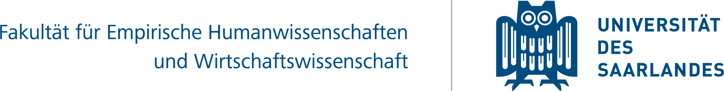

Bachelor‘s/Master’s degree CERTIFICATE

Leibniz-Preisträger
9

The Faculty of Human and Business Sciences at Saarland University
represented by the Dean
Univ.-Prof. Dr. pol. Stefan Strohmeier
hereby confers upon

Ms / Mr Titel Vorname Name
born on DD Month YYYY

the academic degree of

Master of Arts (M.A.)
in the Master’s degree programme

Master-(Blended Learning)
Of Evaluation (Mable)

and awards the final grade of grade designation (X.X).

Date of final assessment or examination: DD Month 20YY

Saarbrücken, DD Month 20YY
The Chair of the Examination Board
Master-(Blended Learning) of Evaluation (MABLE)
Univ.-Prof. Dr. phil.
Reinhard Stockmann
The Dean of the Faculty of Human and
Business Sciences
Univ.-Prof. Dr. pol.
Stefan Strohmeier

